Statement and Confirmation of Own Work



***A signed copy of this form must be submitted with every assignment.***

***If the statement is missing your work may not be marked.***

**Student Declaration**

I confirm the following details:

|  |  |
| --- | --- |
| **Student Name:** | Johnson Kenisha Corera |
| **Student ID Number:** | c23020001@cicra.edu.lk |
| **Qualification:** | Bachelor in Cyber Security |
| **Unit:** | SIT325 Advanced Network Security |
| **Centre:** | CICRA Campus |
| **Word Count:** | 594 |
| I have read and understood both *Deakin* *Academic Misconduct Policy* and the *Referencing and Bibliographies* document. To the best of my knowledge my work has been accurately referenced and all sources cited correctly.  I confirm that I have not exceeded the stipulated word limit by more than 10%.  I confirm that this is my own work and that I have not colluded or plagiarized any part of it. | |
| **Candidate Signature:** |  |
| **Date:** | 03/12/2024 |

**Task 9.2C**

**Table of Content**

Physical layer security………………………………………………………………………05

DAE…………………………………………………………………………………………06

Method………………………………………………………………………………………07

Output……………………………………………………………………………………… 08

Overview……………………………………………………………………………………08

**Table of Figures**

Figure 01……………………………………………………………………………………09

Figure 02……………………………………………………………………………………10

Figure 03……………………………………………………………………………………11

Figure 04……………………………………………………………………………………12

Figure 05……………………………………………………………………………………13

Figure 06……………………………………………………………………………………14

|  |  |
| --- | --- |
| **Acronyms** | **Meaning** |
| SNR | Single-to-noise ratio |
| DAEs | denoising antoencoder |

**Table of Acronyms**

**Physical layer security**

* The newly emerging security field called physical layer security depends on transmission environment features to enhance system security. Secure physical layer security differs from conventional cryptographic approaches to protect physical layer information transmissions through the use of transmission media attributes.

**Fundamental concepts**

* The maximum data speed which achieves secure transmission through a communication channel defines secrecy capacity. The security capacity analysis takes into account all potential wiretapping methods along with the channel transmission capabilities.
* Your code uses auto encoders to assess the entire dataset but its main objective focuses on detecting anomalies and pays no attention to physical layer security aspects. The regulations may impact the development and dependability of these systems particularly for data transmission through unstable networks.
* The Signal-to-noise ratio (SNR) when improved through various methods helps enhance communication channel security and reduces its reliance. Spread spectrum combined with multiple antennas function as methods which enhance the signal to noise ratio known as SNR.
* A wiretap channel describes the circumstances where an outsider tries to overhear a conversation. The goal of physical layer security is to convert received signals into unintelligible content for unwarranted listeners.

**DAE**

* Neural networks perform anomaly detection as their primary function under the name denoising auto encoders (DAEs). Unsupervised learning utilizes these systems to perform its operations. Training DAEs results in learning to reconstruct input data from noisy data versions. The primary basis for this work demonstrates the poor reformatting capability of typical data to recreate anomalies or outliers.

**Method**

* Testing control occurs through auto encoder reconstruction calculations that lead to measurement of reconstruction errors. A data point becomes anomalous where the error exceeds a predetermined threshold under a decided inclination.
* The training process in Phase of Training uses standard data to extract underlying patterns and correlations from the data. During its operation the technique works to minimize reconstruction differences between input data and output data.

**In the code that was supplied;**

* Auto encoders work as an encoder decoder pair for achieving their operation. The encoding process combined with decoding processes data input which receives motion vector analysis from objects within the image. The model shows that dropout acts as an overfitting prevention method.
* The model uses prognosis to evaluate test data points and identifies which ones exceed the threshold to qualify as outliers.
* Outliers get eliminated from the data collection process because they exist outside the expected range. Information that stays within the predicted parameters remains in the dataset. The training of the auto encoder depends on normal data alongside the testing phase that uses anomalous data.
* For anomaly detection threshold calculation the most important step involves multiplying the mean reconstruction error of the training dataset by its standard deviation amount before adding the result to the average error.

**OUTPUT**

* The accuracy of the anomaly detection model depends on these values because the code executes a comparison between previously generated anomalies and actual labels.

**OVERVIEW**

* The method applies auto encoders to data collections for anomaly detection purposes. The model pathophysiology can be identified through its reconstruction mistakes since the model undergoes training for sample reconstruction tasks. The methodology uses the following steps to accomplish its objective through the provided code: Steps are crucial for training auto encoders – data normalization and threshold choice among them. Additionally, model accuracy testing must be conducted.
* The physical qualities of transmission enhance security performance in communication networks. The implementation concepts included within physical layer security influence data transmission system efficiency along with architecture aspects although the code itself does not specifically state these elements directly.

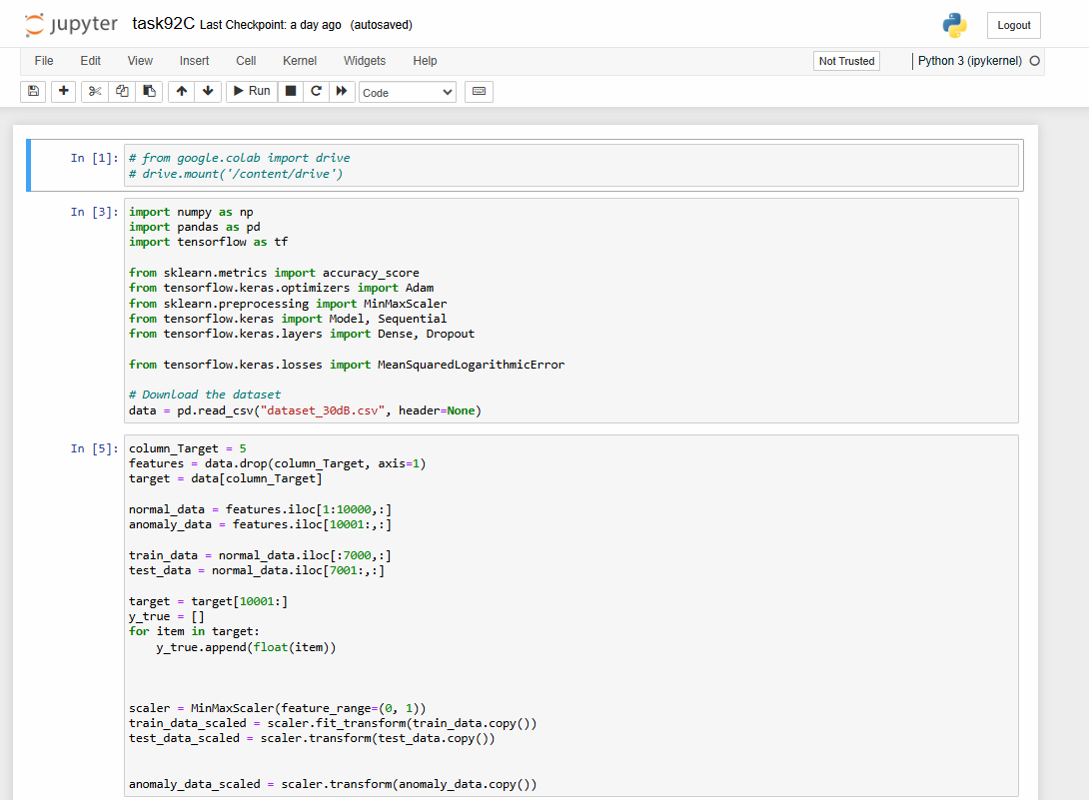

*Figure 01: py Code*

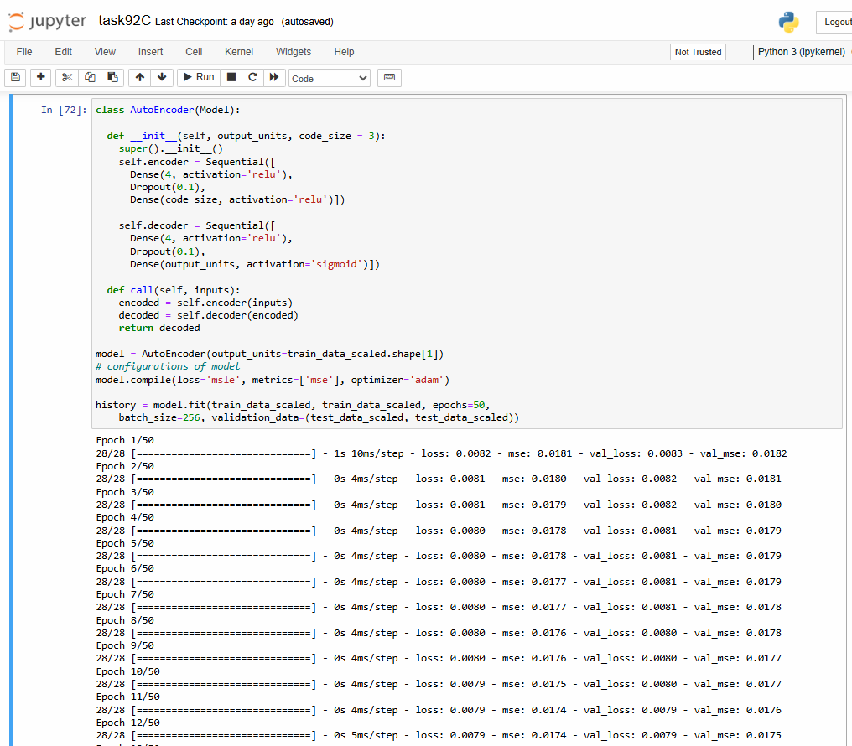

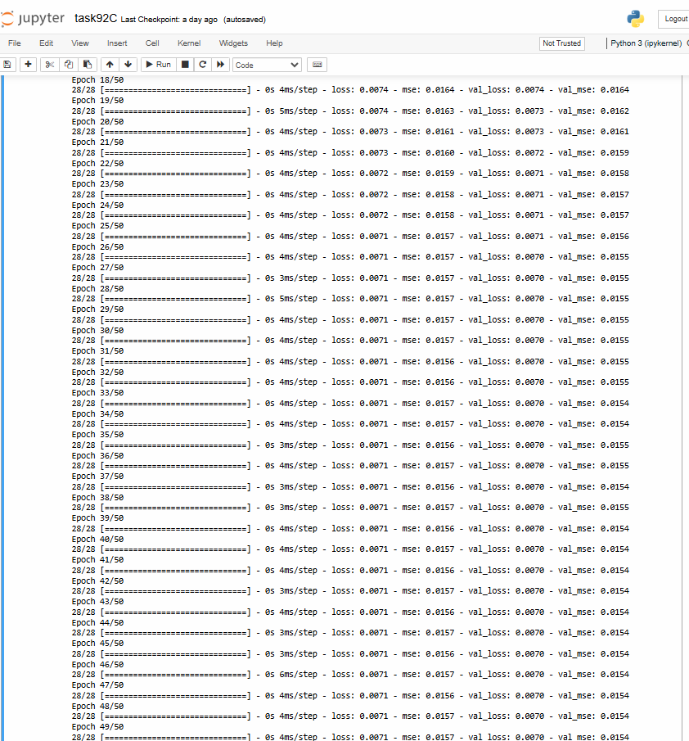

*Figure 02: Running*

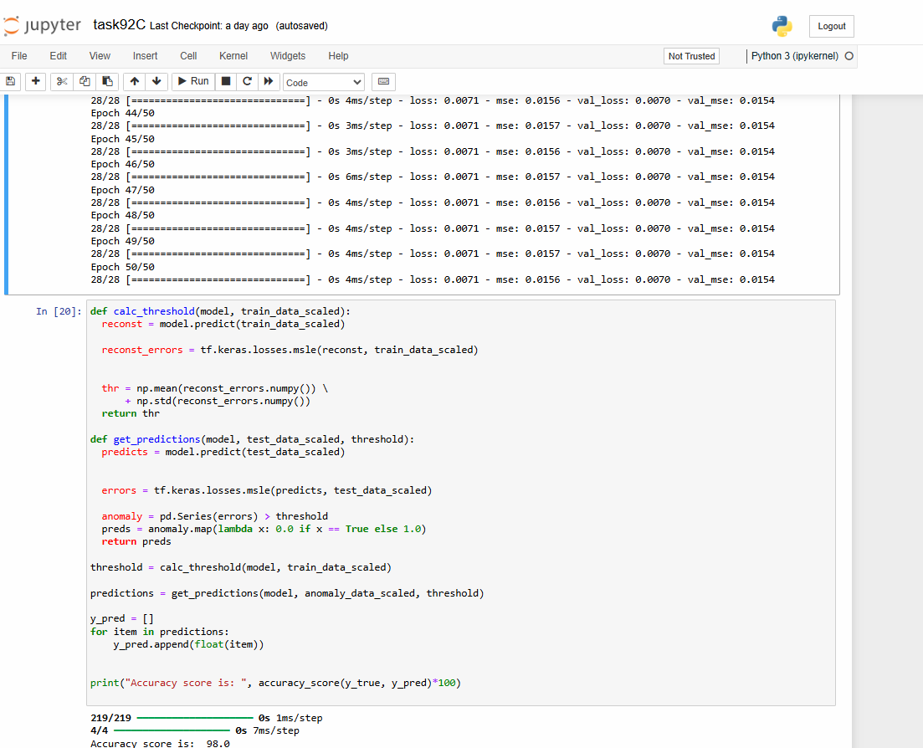

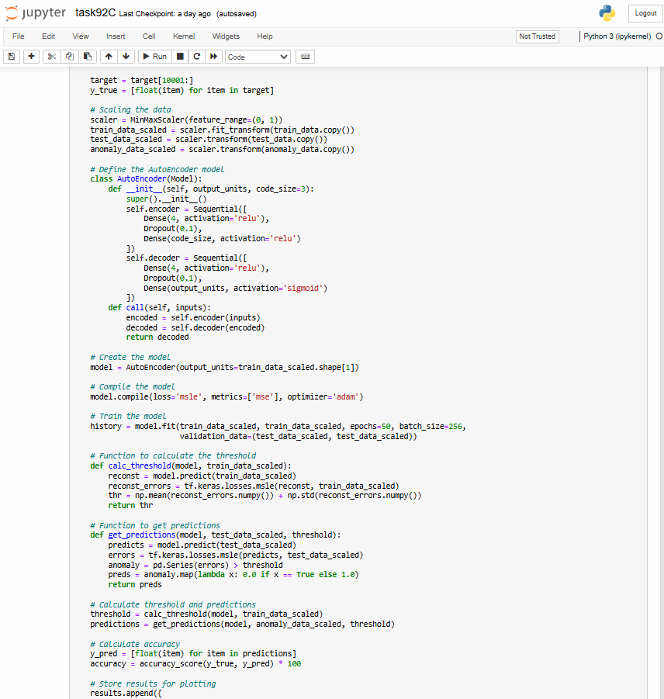

*Figure 03: py code*

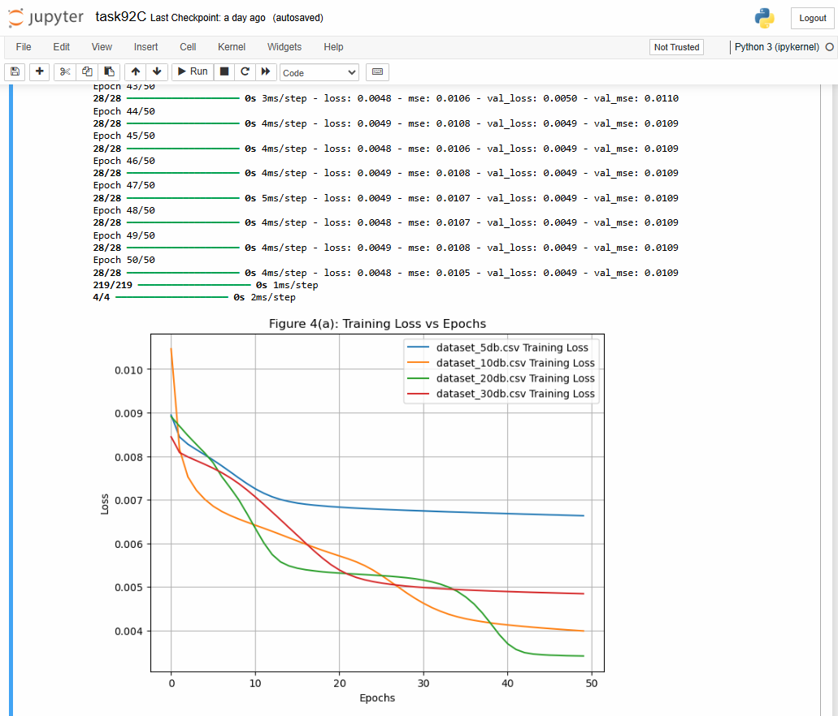

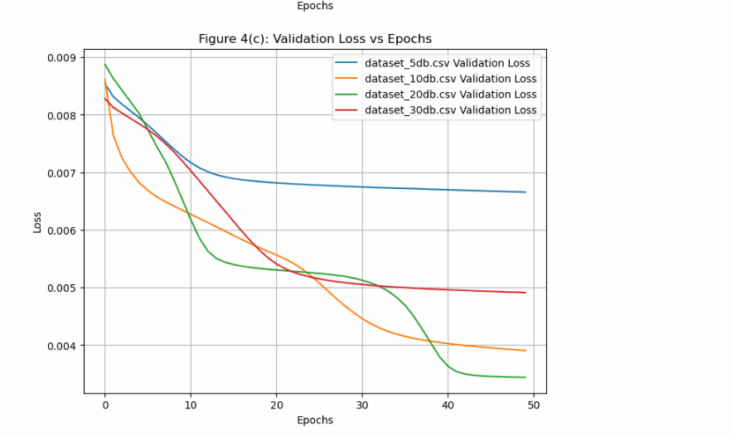

*Figure 04: Output*

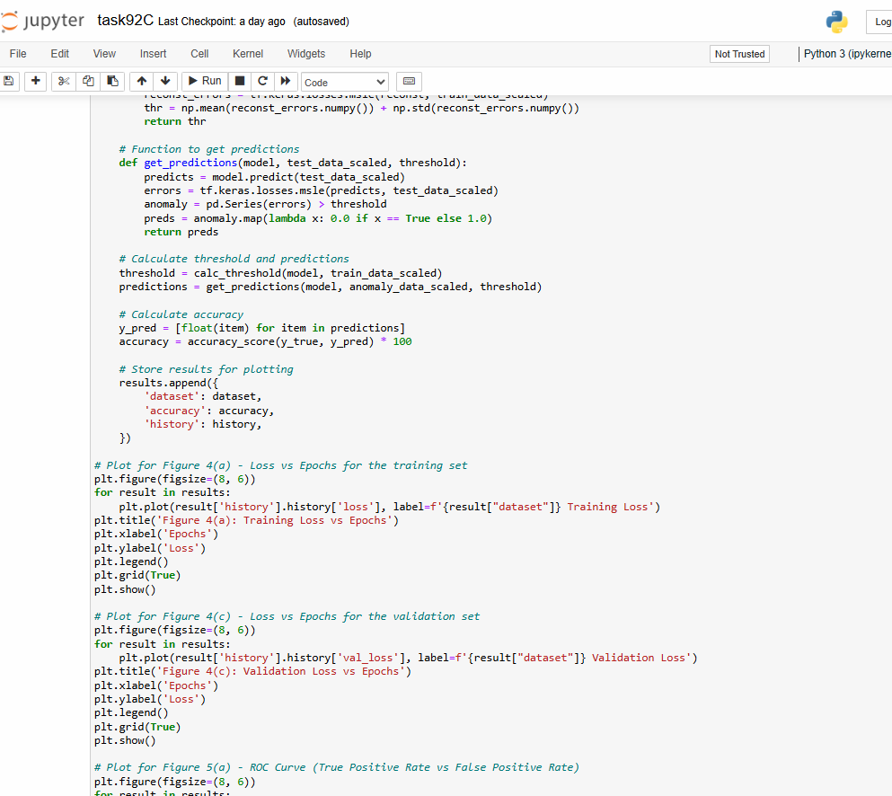

*Figure 05: code to execute*

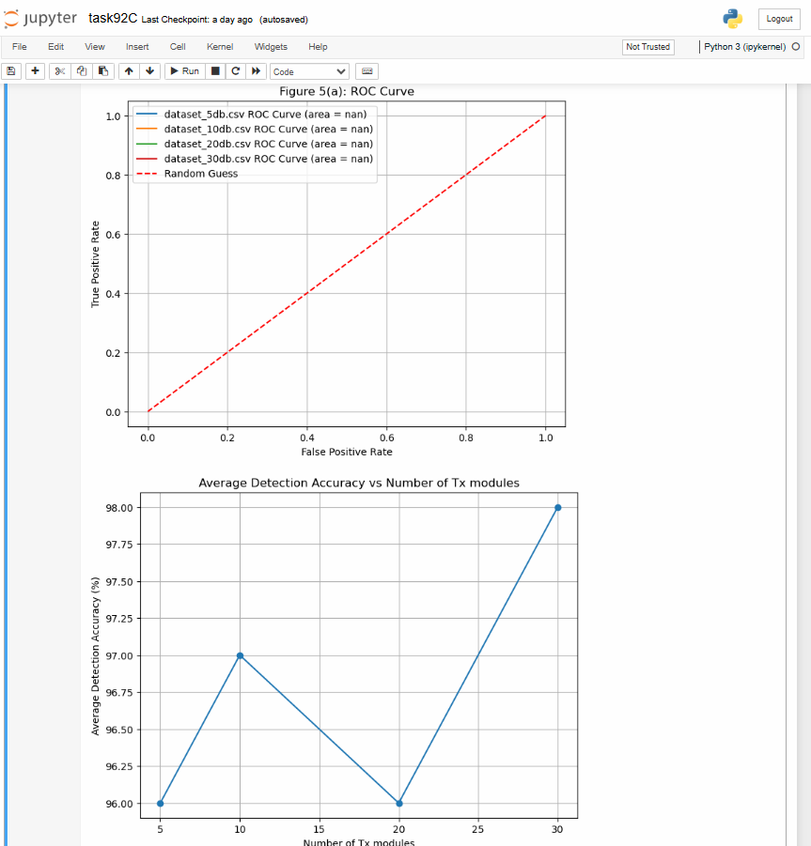

*Figure 06: Output*